Changyuan Pilot DH Project
In November 2013, Changyuan County government and Dunan (Tianjin) Energy Saving Systems Ltd (hereinafter referred to as Dunan ) signed a " Franchise Agreement for District Heating Project Utilizing Waste Heat from Changyuan Power Plant " which stipulated that Dunan makes the investment and construction of Changyuan Dentral Heating Project.

- Project Site and Heating Range:
The project is located in the urban area of Changyuan County, the specific range as follows: the northern ring road to the south, Jingxian Avenue to the West, Daguang Highway to the east and Weisilu to the North
- Construction Scale and Main Content of the Project:
The project will be constructed for the building heating area of not less than 10 million square meters in Changyuan County, the construction period was constructed from 2013 to 2018, district by district and step by step. Phase One Project completed the building heating area of about 3 million square meters; While Phase Two Project completed about 7 million square meters. The Project includes the construction of a new steam-water heat-exchange station, a heating network, district substations and supporting facilities

3. Heat sources and Technical Solutions:
Henan Xinzhongyi Power Plant, 2 * 660MW supercritical generation units is used as the project heating source. The main heat-exchange station, utilizing turbine steam as the heat source (in the long-term, waste heat recovery of cooling water from power plant will be used as the supplementary heat source) makes high temperature hot water which works as the primary heating media to make heat transfer through the substations to supply the heating to the buildings.
- Investment & Financing:
The total investment of the project is about 450 million RMB, and the financing comes Dunan itself.
5. Environmental Effect
After the project fully completed, there will be annual savings of about 45,000.00 tons of standard coal, about 16,000.00 tons of carbon dioxide reduced emissions, about 893 tons of sulfur dioxide rudeced emissions, 312 tons of nitrogen oxide reduced emissions which are equivalent to planting 6, 340,000.00 trees, there shows a great environmental impact.
6. As mentioned above, the heat source of this project is Henan Xinzhongyi Power Plant (2 * 660MW unit), in long-term the project will adopt steam driven lithium-bromide absorption heat pump, using turbine extraction steam (steam pressure 1.0MPa-0.345MPa) as the driving heat source going through the main heat exchanger station to get 110 ℃/50 ℃ high temperature hot water to supply the heating to Changyuan County. At present, the main heat-exchange station works through the steam-water heat exchange for the heating supply, in long term, the primary return water goes through absorption heat pump from 50 ℃ to 85 ℃, then through original network heater to heat the water further to 110 ℃ to provid the heat to the city. The industrial and civil construction area is about 25 million square meters, and the heating area is expected to be 12, 250,000.00 square meters, with a heating rate of 49%. The heat heating load is 539.48MW, the annual heat supply is 3,934,000.00 GJ, the heating radius is 18.07km and the maximum diameter is DN1000.
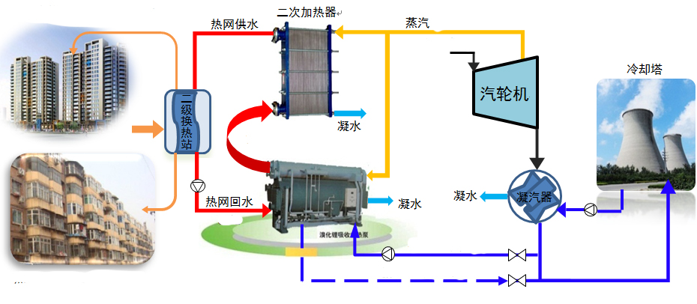
7. Henan Xinzhongyi Power Co. Ltd. is located in the central part of Changcun Town, under the jurisdiction of Changyuan County Xinxiang City, 10km east to Changyuan County Downtown, 1.0 km south-east to Changcun town, 150m south to Provincial Road S308. Originally it was Phase 3 Xinxiang Power Plant 2 * 200MW units, jointly invested by Henan Provincial Construction & Investment Co., Ltd and Xinxiang Municipal Construction & Investment Co., Ltd, the company was then Henan's largest Sino-foreign joint venture in power generation and has made important contributions to Henan province's power construction and economic development. The Xinzhongyi Power Plant 2 * 600MW units, as the large thermal power enterprise, was constructed on the basis of shutting down the original Henan Xinxiang Zhongyi power plant 2 * 220MW units. And it is not only an important project which Henan Construction & Investment Group responds to the national "Construct Bigger Units, Shut-down Smaller Units”policy to achieve the sustainable development, but also in Henan province a key project to optimize the structure of power industry to promote energy-saving emission-reduction. The project started construction in February 2013 and the first unit was put into operation in January 2015, and the second in April 2015.
8. Up to 2016 - 2017 heating season, the project completed, the construction of the main pipeline trench 37919.1 m (75838.2m pipes including supply and return), the construction of the primary pipeline trench 10868.9 m (21737.8 m pipes including supply and return), the construction of the secondary network covering an area of 525,900.00 square meters, the construction of 40 substations. In 2017 - 2018 heating season, it is expected to build the main pipeline trench 10220 meters (20440 m pipes including supply and return), the primary pipeline trench 2310 meters (4620 m pipes including supply and return), the secondary network covering an area of 623,000.00 square meters, 21 substations.
9. In 2016-2017 heating season, totally 34 substations (including 2015-2016 heating season 16 substations in operation), totally 45 substation units (including 2015-2016 heating season 21 units in operation ) in which 2 sets from Beijing Boda, 19 sets from Jinzhong Ruiyang, 24 sets from Liaoning Tianyu.
Operation Substaios Up to 2016-2017Heating Season
Boerduo | Puchenggongguan | Yujinglongyuan | Hongxitai | Huaidexiaoxue | Nanpujiayuan | Zizhuyuan
Futianhuayuan | Shiboyuandongqu | Changchengrenjia | Tianyuhuayuan | Laimenghu | Zhongyanghuayuan | Guiyuanxiaoqu
Huataihuayuan | Dishuishuiliju | Zhongguoyinhang | Yangguangjiayuan | Zhongyiyuan | Hongdawenquan | Jianyesenlinbandao
Jianshedasha | Yilongguojicheng | Jianchayuan | Taijiyuanxiang | Hewuju | Dongfangfudi | Changchengzhongxue
Ouzhouxiaozhenyiqi | Yilongzhongyanggongguan | Youyihuayuan | Huazhishangshijicheng | Honglixincun | Fumeixiaoqu | Total: 34 Districts
The main heat exchange station of this Changyuan project is operated by the power plant, and ,the water consumption and power consumption of the power plant have not been counted. In 2016-2017 whole heating period,the heat consumption for all the substations is 493796.52 GJ, the power consumption is 1051235.19 Kwh, the water consumption is 59233.70 t. Considering the heating area of 1,132, 275 square meters, heat consumption of 0.436 GJ/㎡; electricity consumption 0.928 Kwh/㎡, water consumption 0.052t/㎡.
10. This project utilizes monitoring & Analysis Software from Beijing Boda Xingchuang Co.,Ltd which can realize the operation control, data analysis and other functions. Currently those 45 substation units are all controlled automatically covering temperature compensation control, indoor temperature control, secondary temperature control, pressure and temperature difference control functions, but through the test run, there was a high rate of customer complaints which means the automatic logic and the actual project does not match each other, all at present the manual control applys for the heating.

